September 2026
OADBY HILL WALKING CLUB NEWSLETTER
v

Contents
Club Announcements 2
Walking Routes 2
Walking Boots 2
Photography Consent 2
2026/2027 Monthly Walk Destinations 2
OHWC New WhatsApp Community 2
Safeguarding 3
Club Members’ Stories 3
Market Harborough Park Run 3
Cycling from Warsaw to Leicester 4
In Memory of Andy McQuaid 5
Lake District Trip – May 2027 6
Derwentwater Hotel, Lake District (1st / 5th May) 6
Last Call for the Dolomites Hiking Trip – June 2027 6
Arabba (24th June / 2nd July) 6
WALKS 8
September’s Monthly Walk Report: Longnor (Peak District) 8
September’s Mid-Month Local Walk: Wood House Eaves 10
October’s Monthly Walk: Langsett (Yorkshire – Dark Peak) 10
Coach Departs 10
Walk Leaders: 11
Pub 10
Map 10
Booking Trips 11
Coach Fare 11
Cancellations - Members & Guests 11
Prospective Walkers 11
Walk Route Map 11
Boot/Toilet Stop 12
Essential Wear 12
Looking for Walk Leaders 12
Cotswold Outdoors Discount Card for Club Members 12
OHWC discount 12
Cotswold Outdoors Discount Card 13
Meetings 14
Club Media & Bank Details 15
OHWC Committee 2026– 2027 16

Club Announcements

Walking Routes
Can all club members look at the walking routes available on the OHWC website: https://www.oadbyhillwalkingclub.com, & also on the club WhatsApp group prior to joining each month’s coach trip, so the walk list can be passed round the coach more efficiently please. Each month’s walk routes are put up on the club website in the week before the monthly walk.

Walking Boots
Club members are reminded that when joining club walks, they must wear walking boots with ankle support. The only exception to this rule is if club members have a valid medical reason for not wearing boots with ankle support.

Photography Consent
Please, note that walk leaders & club members will take pictures during our hikes, which are published in our facebook private page, whatsapp private community & club’s website. If you DON’T want your photo to be taken, please remember to let your walk leader know before the walk starts. Also, be mindful to turn your head or step away when group photos are taken.

2026/2027 Monthly Walk Destinations
Adam Wakley has published the monthly OHWC walk destinations from October 2026 to April 2027. See below:
- 01 November 2026 Longshaw, Peak District
- 06 December 2026 Biggin, Derbyshire Peak District
- 03 January 2027 Wirksworth, Derbyshire
- 07 February 2027 Kingsley Holt, Leek
- 07 March 2027 Taddington, Derbyshire Peak District
- 04 April 2027 Andoversford, Cotswolds

OHWC New WhatsApp Community
By now all of you who were on the original club’s WhatsApp group chat may have realised that you have been tele-transported (Star Trek style!) to the Oadby Hillwalking Club Community. Any group chat related to OHWC is under this community now. Join us, if you haven’t yet!
This is how it works. Our OHWC Community is comprised of several groups:
- Announcements: Only admins can post here. Members can like the posts or reply to them, but cannot post. This is where all the important information will be kept, in a nice standalone space, so people don’t have to scroll up & down to find the important bits (i.e., walks maps, routes, dates, events, etc).
- OHWC Chat: This is the chat you always had. Streamlined into a chat about OHWC walking & hiking – share your pics, vids & hiking stories. PLEASE note that any posts out of subject will be moved to the general group by the moderator.
- OHWC Lakes 2027: This chat is for the people who have joined next year’s Lake District Walking Holiday, or would still like to join us.
- General: We would like to make this a space where members can talk about anything & everything we enjoy without taking over the main OHWC Chat group – talk about our own travelling, hobbies, share interesting articles or videos, petitions, etc. It would be great if more people from the community join. We have 17 members. PLEASE aim to use this group for all non-OHWC, walking or hiking related posts.
Once you join the community, you can choose what group chat you want to join, stay on or leave. You can request to join groups if you automatically are not added, & if you don’t want to participate in the chats, then you can just stay only with the announcements.
I welcome all of your feedback & ideas to improve our WhatsApp community. Let’s make it great!

Safeguarding
The OHWC is committed to safeguarding in line with national legislation, & national & local guidelines. We ensure safeguarding by ensuring our club is run in a way which keeps our club members safe.
We all have a responsibility to safeguard adults & young people who are experiencing, or are at risk of, abuse & neglect. The OHWC is committed to creating a culture of zero tolerance of harm to our club members which necessitates:
- The recognition of club members who may be at risk & the circumstances which may increase risk.
- Knowing how abuse, exploitation or neglect manifests itself.
- And being willing to report safeguarding concerns.
The OHWC Safeguarding Policy & associated procedures apply to all individuals who are involved in the OHWC, including the committee & the walk leaders, to all concerns about the safety of club members whilst taking part in club activities,& in the wider community.
All club members are encouraged to report any safeguarding concerns, no matter how trivial they seem to the club at OHWCsafeguarding@gmail.com.All such communications will be treated as strictly in-confidence& will be investigated thoroughly.
The OHWC Safeguarding Policy & Guidance document is on the club website at https://www.oadbyhillwalkingclub.com/safeguarding.html

Club Members’ Stories

Market Harborough Park Run
By Kevin Millard
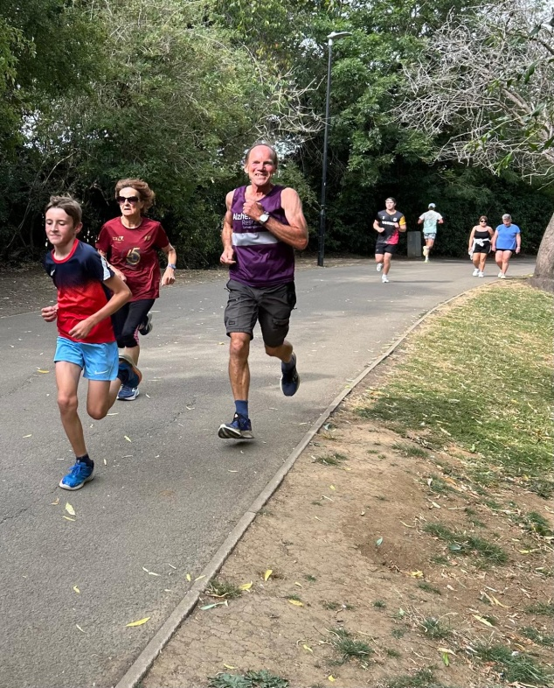 | If you go down to Market Harborough’s lovely Welland Park on a Saturday morning, watch out for Kev Millard & 400 other Parkrunners & walkers all trying to look like they are enjoying the experience while being cheered on by the 30+ volunteers who make sure everyone stays safe. A great start to the weekend. With nearly 1000 locations around the UK, there’s a Parkrun near You!  Market Harborough ParkRun  ParkRunUk  

Cycling from Warsaw to Leicester
By Shirley Thomas

Last month I cycled Warsaw to Leicester to honour my sister who died in April of Pancreatic cancer.  I did it with 3 friends & we followed the Eurovelo2 - Capitals route.  Wished I’d had an electric bike at times! Averaging 55miles a day, fully loaded.  We were cycling a section of the Capitals Route which runs from Moscow to the west coast of Ireland. We decided to start in Warsaw, Poland & the route took us to Trafalgar Square via Berlin & Den Haag & the ferry to Harwich. Then it was down into London. The distance of this trip was 2211km.  Apart from the Hartz Mountains, where I admit to pushing up a couple of big hills, the route was practically flat.  The section in Poland wasn’t very well signposted & we didn’t see other cyclists doing the same route but that changed when we reached the Western part of Germany & saw lots of other cyclists.  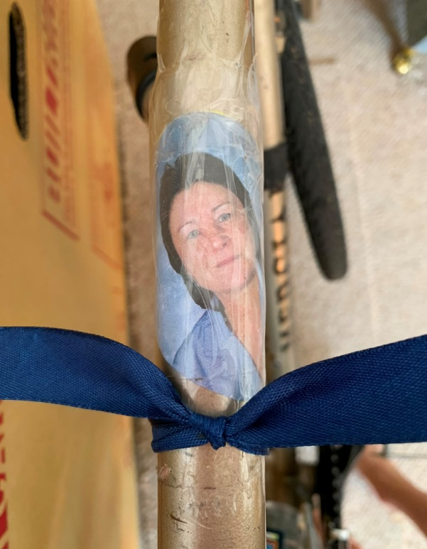 | 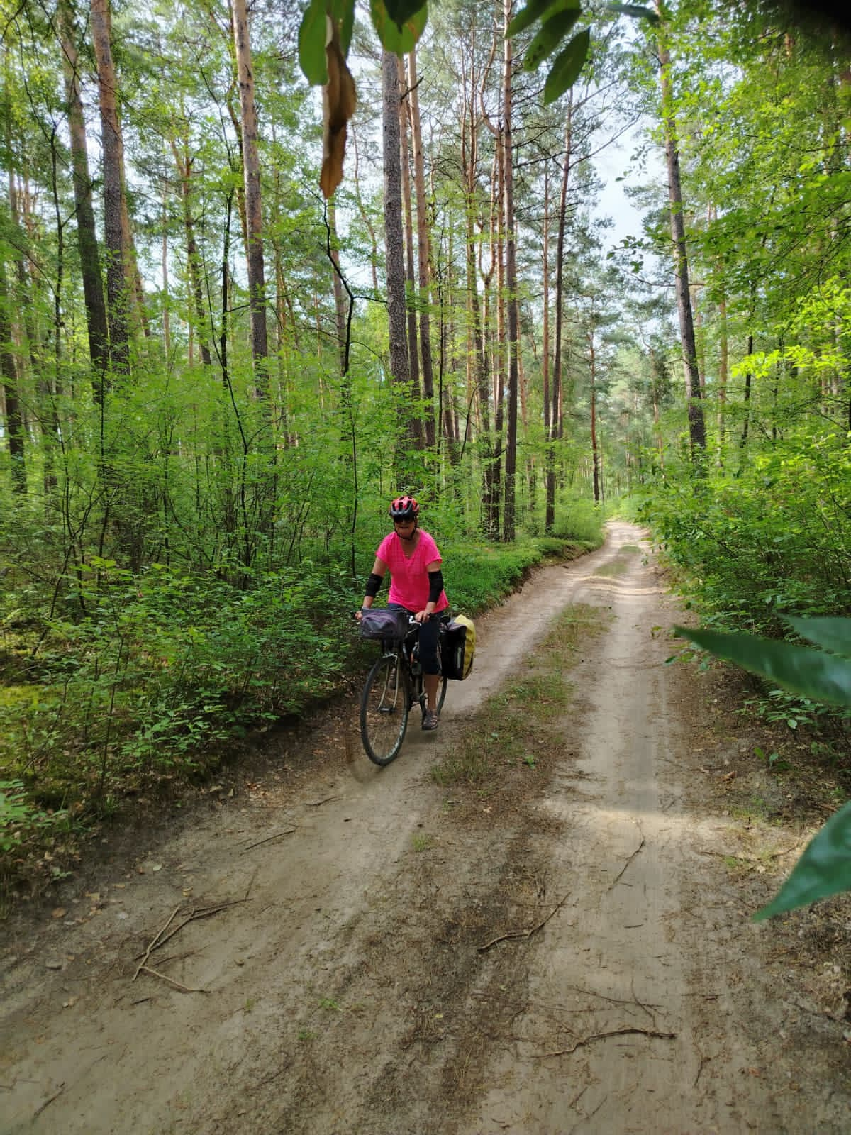  We did a few hotels where there were no campsites. I was the only one to have a minor accident when I skidded on soft sand in Poland.  Germany & Holland are always brilliant to cycle with a really well developed cycle network & good pastries!  As I think I said, I was dedicating the ride to my sister, Jen, who died from pancreatic cancer earlier in the year. Her photo is on my crossbar & I think it will stay there.  On Monday I’m going down to Kent for a solo ride along the Cantii Way, & hoping not to fall off again!

In Memory of Andy McQuaid
By Carol Birch

I am sorry to have to tell you that Andy McQuaid passed away on Monday morning, 31st August, peacefully at Loros. He spent his final days there with his immediate family, & 'drifted off’' early on Monday morning. Right up to the end he maintained his interest in OHWC, always asking me all about the monthly walks & he was very grateful for the kind words & thoughts I passed on to him from so many of you.

Some memories from Andy at the 2023 Lake District Walking Trip:

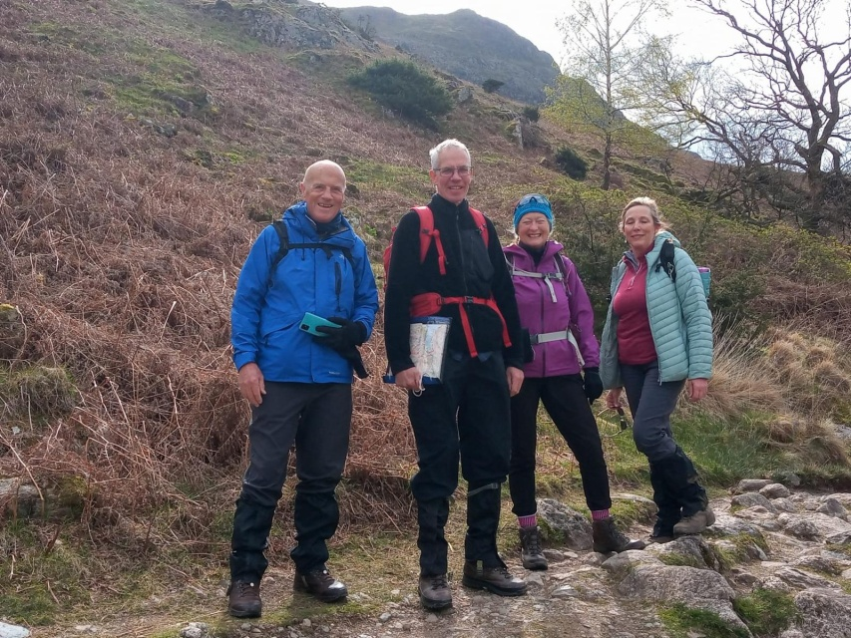
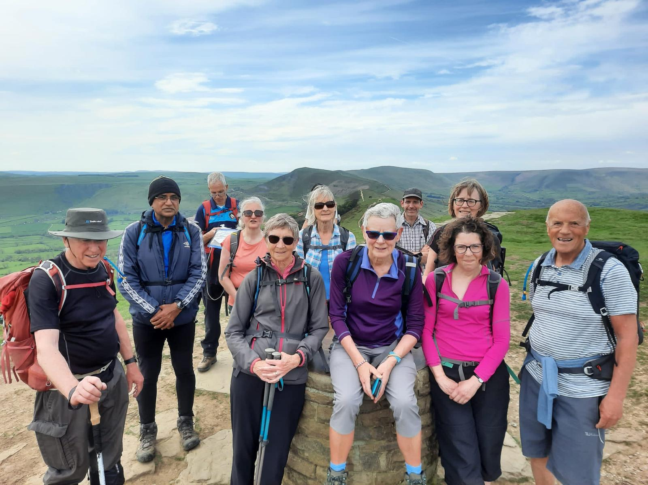
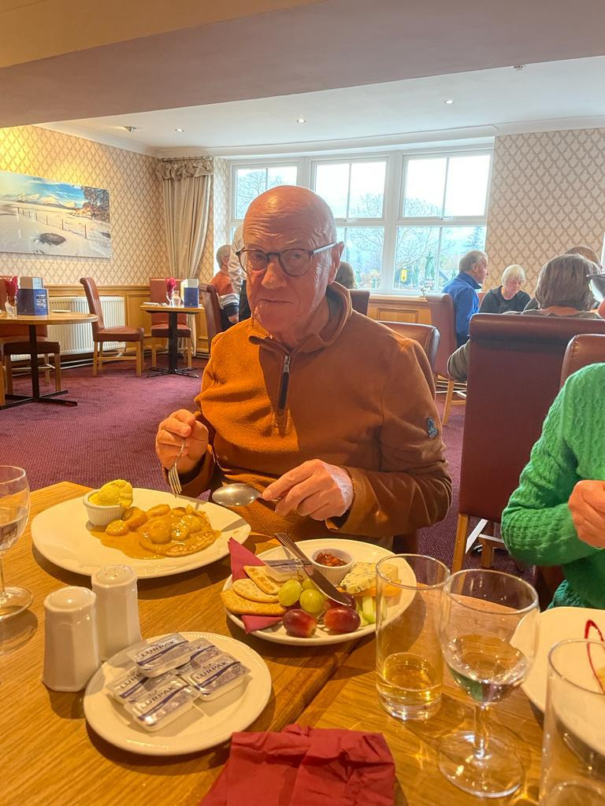

Lake District Trip – May 2027

Derwentwater Hotel, Lake District (1st / 5th May)
There are now 28 members going to the Derwentwater Hotel in May 2027. There may still be some availability if other club members wish to attend the party. Telephone Alfa Travel on 01257 248000 should you wish to make enquiries.
Don’t forget to join our WhatsApp OHWC Lakes 2027 group for all the latest info about the trip!

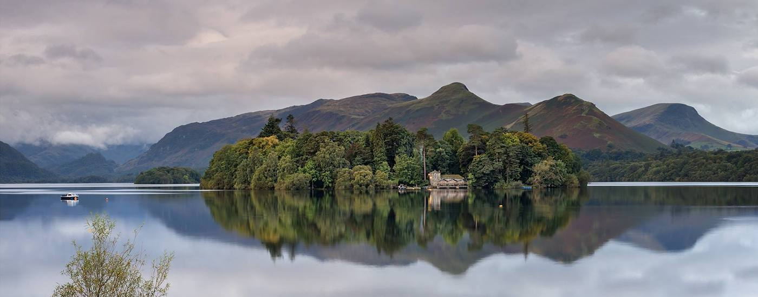

Last Call for the Dolomites Hiking Trip – June 2027

Arabba (24th June / 2nd July)
By Martin Beckett
For 2027’s trip to the Dolomites we would like to change things so that there is less reliance on a limited number of people to organise all matters & lead the walks. We have now settled for the ski resort of Arabba as it’s probably less expensive than Selva in terms of accommodation & lift passes. The provisional travel dates are Thursday 24th June to Friday July 2nd, giving us 7 days walking. The mid week flights would be less expensive.
I have already spoken to Millingtons Travel Agents in Market Harborough who are prepared to help. I have requested flying out to Innsbruck on Thursday 24th June & returning Friday 2nd July. There are 14 in our party, 12 of whom would be flying out and 11 would be on the return flight. We'd be meeting the other 2 at Arabba. There are 4 couples in our party who would require double rooms. Other members of the party are travelling solo & we would want to explore the cost of single rooms for them or alternatively sharing twin rooms. We have stayed in two and three star hotels in the region before. We're not looking for luxury, just good hospitality & food. (Breakfast & evening meal included). We would be looking to use minibus transport from one pickup/return point in the UK (Oadby) & transport to & from the airport/hotel. We have previously stayed over in a Gatwick hotel before our Thursday flight.
We will be encouraging more club members to lead routes assisted by the current leadership to ease the burden on the club's small group of regular leaders (Ideally groups of people, who are prepared to research walks in advance & then collectively lead them). This isn’t difficult for club members as all are competent walkers. There are ski lifts, numerous refugios, the walks are well signposted & well worn. The local maps are good & apps like All Trails, Komoot & Map.me are very good. These apps give you numerous ready-made downloadable routes & this will help in Italy.
I appreciate that all members who signed up need to see the final cost of the trip before committing. As previously mentioned, I have asked Millingtons to find us a functional hotel, near the ski lifts with good food in Arabba. It won't be delux but will hopefully meet our needs. I now need to tell them know the number of rooms we need. If you wish to have a single, double or are happy to share a twin please let me know asap, responding to the email I sent o 28th August to the club members on who expressed an interest in the trip, & I can press on with the research.

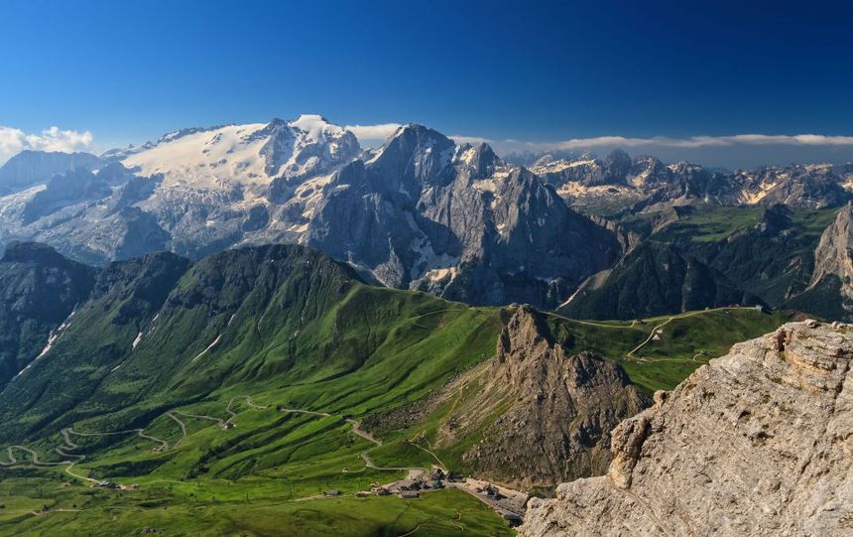

In terms of cost, I haven’t the faintest idea!! In 2024, I brought the trip in with a total cost of £1200 per person. We’re now living in different times in terms of flight costs. A wild guess would be of the order of £1600 for 9 days.
To make transportation manageable, I think the maximum number should be limited to 15 members – 14 members have signed up so far! If you are interested in going to The Dolomites & recognising that you will be asked to participate actively in making the trip successful, please let us know through the club’s email asap, as arrangements have started already & an addition will depend on whether Millingtons can accommodate.
A Dolomites Whatsapp group will be created soon within the OHWC Community so all travellers are able to liaise with each other.

WALKS

September’s Monthly Walk Report: Longnor (Peak District)
By Lesley Gill
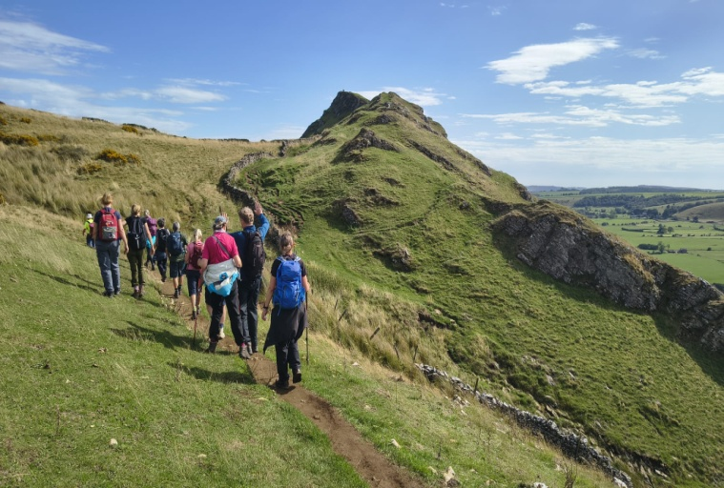
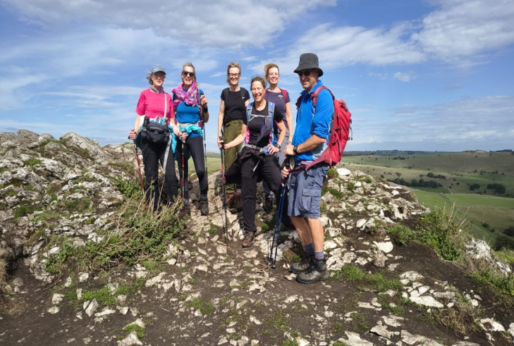
Sunday, 6th September 2026 – Adam’s Walk (10.5 miles / 1718 ft - 523 m elevation)
Adam’s walk took us along very pretty paths & lanes for an hour or so. Then…. We came across another group (not one of ours) peering into the abyss aka Deep Dale. They chickened out & found another route. But not us! A steep & very slippery descent with only one muddy bottom! Back up the other side & coffee break. We admired the amazing rock formations on the side of the Dale, & Karl & Gala bounding down like spring lambs putting us all to shame!  Along the Midshires Way for a while to Cowdale. Then skirting around the edge of Buxton we enjoyed the delight of a very noisy stock car event at the Raceway. Leaving that behind the magnificent Chrome Hill soon came into view. Plenty of photo opportunities! Fears that we were then going up Parkhouse Hill were thankfully unfounded! Phew!  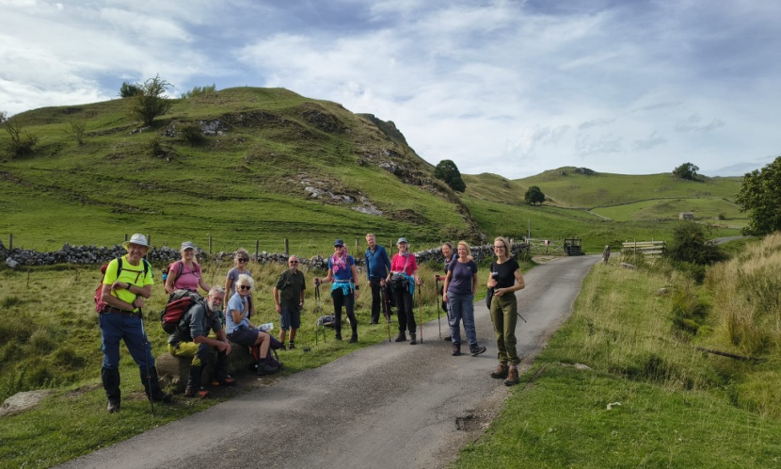  Thank you, Adam!    And some more of your memories from the monthly walks!  “We’re all intrepids, aren’t we?” – Robert, deliberating on whether to take a dodgy path or not!  Bruce | 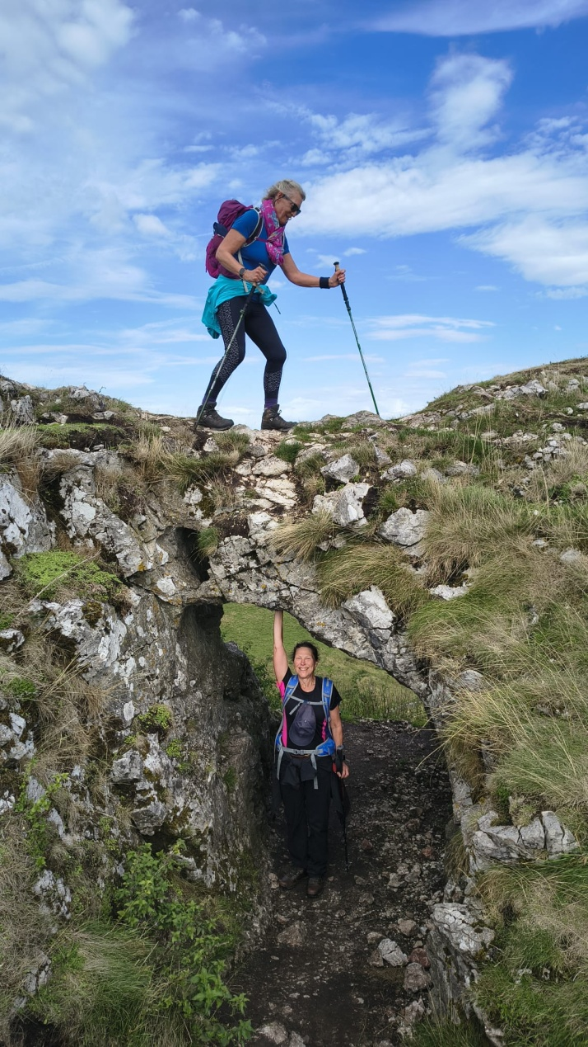  So close to the end we hit a badly overgrown, boggy & badly signed section of the path. A bit of unofficial rerouting by a grumpy farmer perhaps?  The excellent Ye Olde Cheshire Cheese Inn awaited & for some a cosy cafe that stayed open until 5.00pm. Absolute heaven for a certain Mr Bastow!  Excellent walk as always Adam & the weather was kind. Many thanks from us all.  “Thank you Karl for another amazing and challenging walk! Really enjoyed it”  Zahra
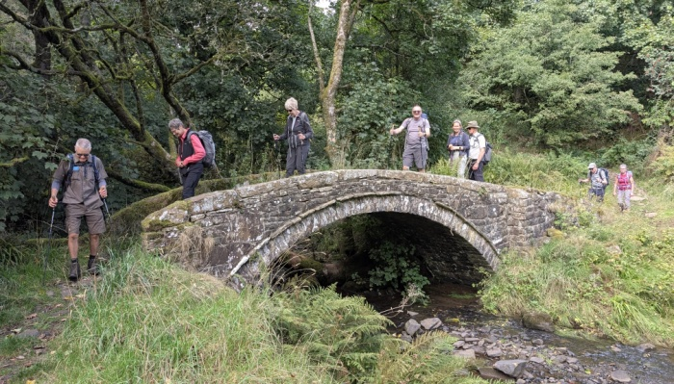  “Sunday’s long walk ticked all the boxes for me, Great company, Great scenery, Great weather, Both sets of Chee Dale stepping stones, a pub stop at lunchtime and Chrome Hill in the afternoon.  No wonder I was sleeping all the way back to Leicester!”  Kevin M.  “Thank you Kev for an excellent walk yesterday. Hot chocolate courtesy of Cobbles Cafe in Longnor”  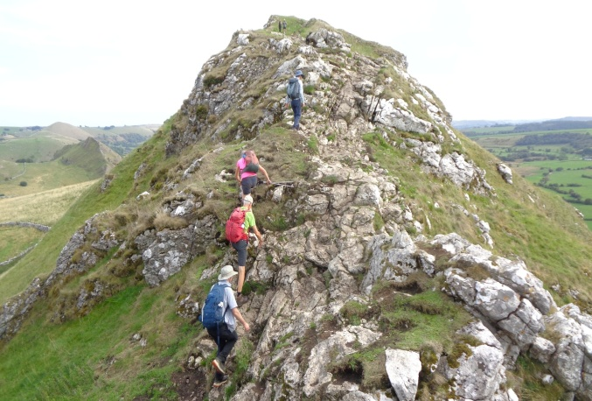  Anne W. | “Best scrambling ever!!!!!!!! We need an offshoot of the club "The Oadby Scrambling club"!!!!!! Thank you, Karl! Please more of this”  Gala  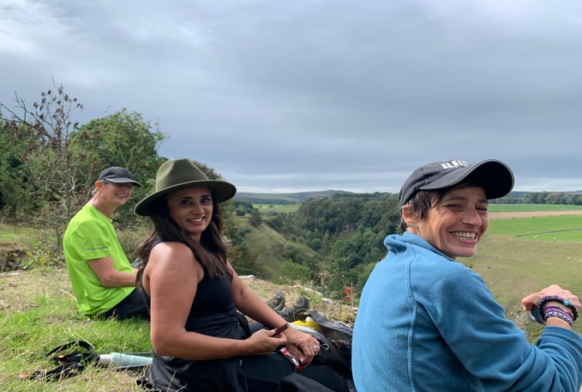  “Many thanks Adam. Great photos and beautiful walk”  Connie  “Many thanks Adam - a lovely walk and great photos too”  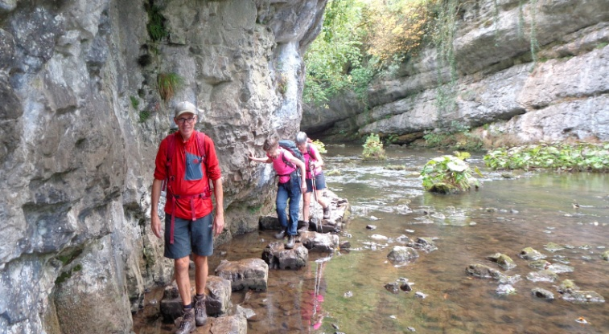  Julie P.

September’s Mid-Month Local Walk: Wood House Eaves
Led by John Bastow & Colin New (not new Colin!)
Sunday 13th September 2026 – Wood House Eaves (8 miles / 750 ft elevation)
John & Colin have kindly offered to lead Septembert’s Mid-Month Walk. Find all the details below:  Meeting Time: 09:30am (Please, arrive 15 minutes earlier – bring a snack & drink)  Meeting Place: Woodhouse Eaves car park, LE12 8RZ (free parking & toilets – also ok to park on the road)  Public Transport: 154 Centrebus to Loughborough (Windmill Rise Stop – 1 bus per hour))  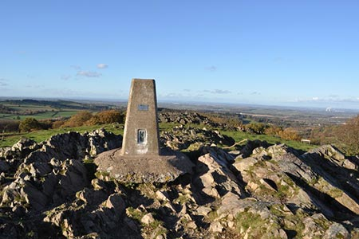 | 
Walk Route:
From the car park we go across fields towards the village of Woodhouse on footpaths & quiet lanes. Then from the edge of Woodhouse Eaves we head towards Beacon Hill Country Park to a cafe where we'll have a snack for a maximum of 20 minutes. Refreshed we'll head to Beacon Hill’s summit & trig point. On our return, we head through Broombriggs fields on route to the car park & our vehicles.

Please, text John if you would like to join this walk on 07771 786699

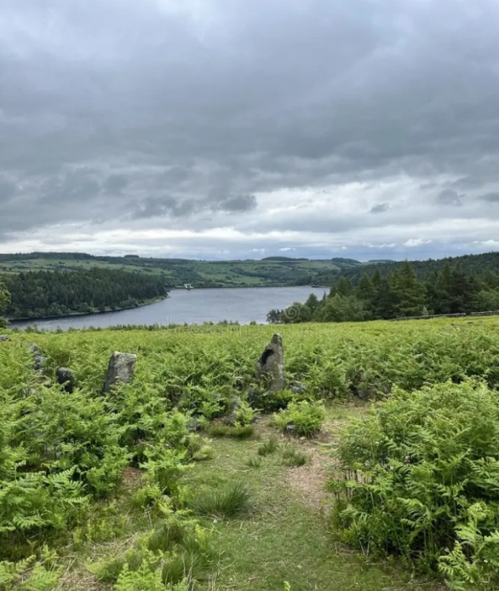
October’s Monthly Walk: Langsett (Yorkshire – Dark Peak)
Sunday 4th October 2026
Coach Departs: Oadby Central Car Park (adjacent to the Trinity Methodist Church) at 8.00am sharp. | Walk Leaders:  Click on each leader to see their route’s OS map  - Kevin Millard (Long-14 miles)  - Karl Pochin (12 miles)  - Alison Beckett (11 miles)  - Adam Wakley (10.5 miles)  - Robert Davison (10 miles)  - Helen Everett (Short - 8 miles)

Boot stop: Woodall Service Station
Pub: Waggon & Horses
*Please note: The coach will leave the pub at 5.30pm.
Map: OS Explorer OL1: OS Map of the Peak District – Dark Peak Area
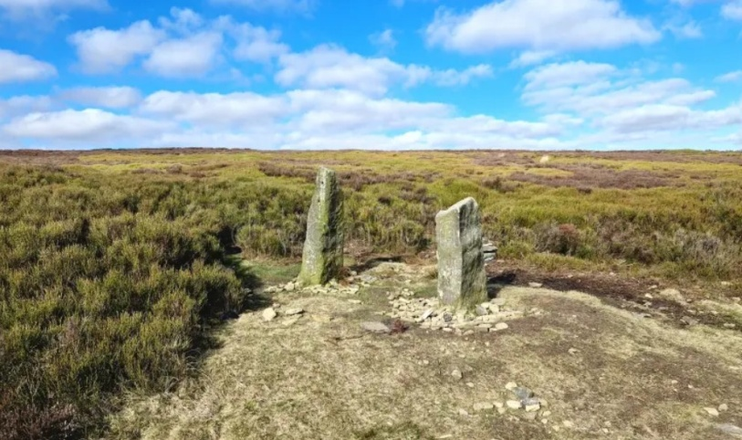

Booking Trips
When booking onto monthly & mid-month walks, please only use the club email rather than phone, text or word of mouth. Alternatively, for the monthly walks, put your name down on the list passed on the return monthly bus.
Coach Fare
Preferably by BACS to the bank details given at the end of this Newsletter.
- Adult Members £18
- Guests £20
- Junior/Student Members £12

Cancellations - Members & Guests
- Cancellations up to Tuesday midnight before the Sunday walk - no penalty.
- Cancellations thereafter - the full cost of the bus fare is due.

Prospective Walkers
If you have not put your name down on the list passed on the last coach trip, please contact ohwcmail@gmail.com to book a seat on the bus this month, prior to making a payment. You will receive a reply confirming the availability or otherwise of a seat. Please note that it is first come first served.
If you delay booking, you may not get a seat. Please do not turn up without booking & receiving confirmation that you have a place.
You must book a place on the coach in advance, or you may not be allowed to go on as it picks up members who have already booked a seat at various places on the ring road.
If you wish to be picked upfrom other places than Oadby Car Park, please mention where at time of booking& please be aware that very occasionally another Orbit coach may go past before ours arrives.
Walk Reminder
Essential information for all OHWC walks can be found on the OHWC Website here.Please ensure that you carry your completed Club Safety Form in the top pocket of your rucksack - it could help you in a difficult situation. N.B. Don’t forget to keep the form up to date. The form is available on the Club Website here.

Walk Route Map
Please go onto the News section of the Club website here, the Announcements section of our WhatsApp Community or our closed Facebook group, a few days before the monthly walk, to see a map showing the walk routes as well as the individual routes. Hopefully, this will speed up selecting your walk when signing up on the coach. The club has four to six OS maps available for Walk Leaders to use when leading walks.

Boot/Toilet Stop
Members are urged to keep the time taken at the boot stop to a minimum. At the end of the walk members should change their footwear & place dirty boots & rucksacks in the luggage locker before getting onto the coach, thus avoiding any congestion & mud in the coach.
Please do not wear dirty boots on the coach.
Those getting off the coach at Fosse Park & the Ring Road may alternatively put your dirty kit into a plastic bag & then take it onto the coach; thus, negating having to search for your gear in the bus luggage lockers.

Essential Wear
Members& guests must be suitably equipped. As a minimum this must include:

- Suitable waterproof walking boots that have adequate ankle support
- Waterproof coat & over-trousers
- Warm clothing
- An appropriate rucksack.
- Food & drink for the whole day
- For winter walking, all members are to carry a serviceable head torch in their rucksacks.
- A First Aid Kit is recommended

N.B. Jeans & trainers/sandals are NOT suitable. If you are not properly equipped for hillwalking, you may not be able to participate. Only Registered Assistance Dogs are allowed on club walks, except on mid-month walks at the discretion of the Walk Leader.

Looking for Walk Leaders
We are having some issues finding available walk leaders, mainly for our local Mid-Month Walks. We would like to encourage members, who may or may not have ever led before, to give it a go! You will receive training & you will not be on your own, as you will be accompanied by an experience leader during your initial walks. All Trails, Komoot & OS Maps are good navigating apps for starters. You can download them on your phone & use off road maps for a small yearly subscription fee.

Cotswold Outdoors Discount Card for Club Members
Once again, Cotswold Outdoors has allowed all Club members to apply for a Discount Card. This discount is for the personal use of club members only & must not be shared with others.
Club members benefit from:
- 15% discount in-store & online,
- Expertise, advice & guidance,
- Sustainability services,
- Explore More membership.

OHWC discount
OHWC Club Members will receive a 15% discount on full-priced items (excludes electronics & selected lines) both in-store & online with Cotswold Outdoor, Runners Need & Snow+Rock. The code to use is AF-RAMBLERS-MBB.
This discount is strictly for personal use only & must not be shared with non-club members. Cotswold Outdoors reserve the right to amend or cancel it with immediate effect if they find this code has been leaked to unauthorised persons in any way.

Explore More
Club members will need to sign up for their free Explore More benefits scheme to use the discount. This comes with its own benefits such as a 3-year warranty, a 100-day returns policy, Price Match Promise & much more! Members can sign up through any of the following brands:
- Cotswold Outdoor
- Runners Need
- Snow+Rock

Expertise, advice & guidance
The best way to tap into their outdoor expertise is for Club Members to book an in-store appointment at Cotswold Outdoor, Runners Need or Snow+Rock. This ensures one of our store specialists is on hand to help you get the best kit for your adventure.
Alternatively, Cotswold Indoor has a whole host of blogs online in our Advice & Inspiration areas. These include kit guides, itinerary ideas, inspirational stories & suggestions on how to be more sustainable. You can find these below:
- Cotswold Outdoor
- Runners Need
- Snow+Rock

Sustainability Services
For us the outdoors is everything, & across our three brands, we do everything we can to look after it for generations to come.
As a company, Cotswold Outdoors are working to become more sustainable, & they want to help their customers do their bit too. The services they offer to help with this are available across all their stores:
- Make The Right Choice
- Care & Proofing
- Recycle My Gear
- Recycle My Run
- Our planet

Cotswold Outdoors Discount Card
This year, Cotswold Outdoor, Runners Need & Snow+Rock have requested that OHWC Club members provide some sort of Club Membership Card to receive their discount. To that end, the club committee has decided to produce a Membership Card for club members to use if they want to take advantage of the discount offered.
I would suggest that members keep a photo of the OHWC membership card & the Ramblers Card together in their phone wallets for use in the stores.

*Please print the next page, & cut out the cards illustrated below*



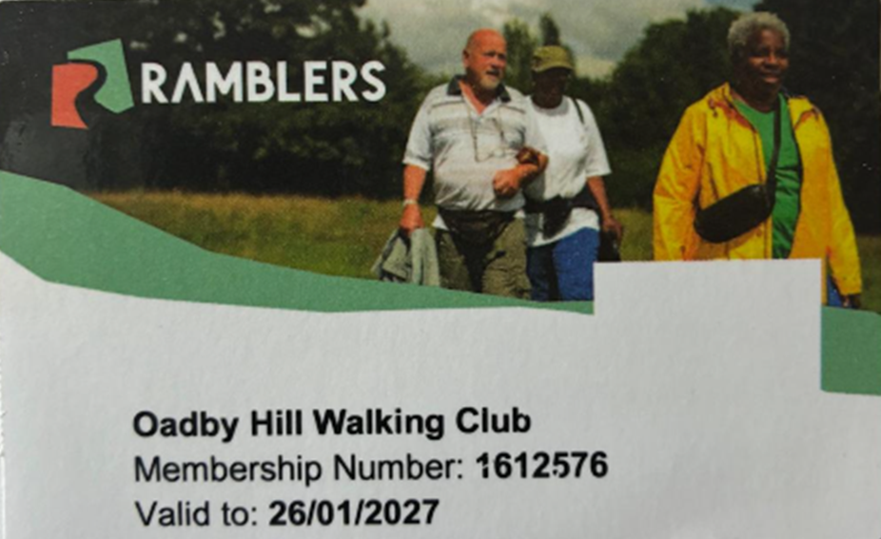

Meetings
Unless otherwise stated in this Newsletter or via email, monthly club meetings are held on the Tuesday following the Sunday coach walk at either the Wigston Conservative Club, 38 Long Street, Wigston, Leicester, LE18 2AH or The Blackbird Pub, Blackbird Road, LE4 0FW at 7.30pm.
October’s meeting will take place on Tuesday 6th. All OHWC club members are welcome.

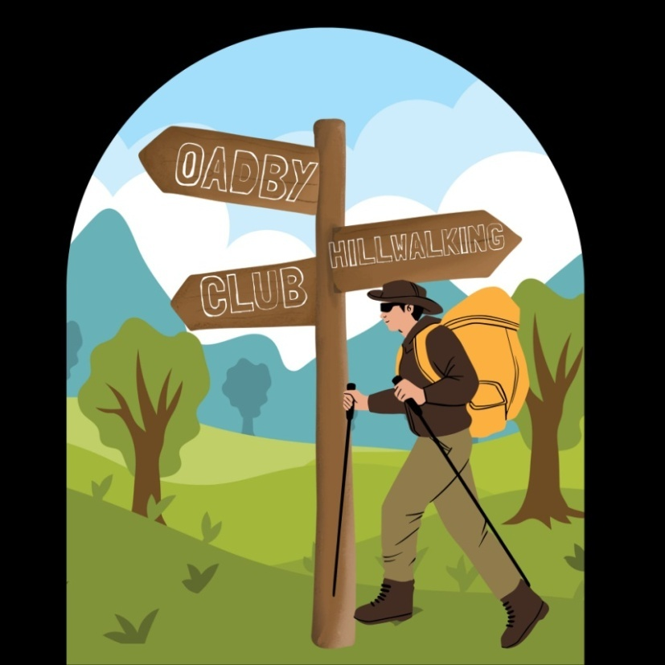

Club Media & Bank Details

Website | www.oadbyhillwalkingclub.com
Email | ohwcmail@gmail.com
Safeguarding Email | OHWCsafeguarding@gmail.com
Facebook | Private Group: Oadby Hillwalking Club group  Public Page: OadbyHIllwalking Club
Instagram  WhatsApp | Oadby Hillwalking Club  OHWC WhatsApp Community
Bank Details | Barclays Bank
Account Name | OHWC
Account Number | 50124990  Please quote surname & month of walk  (i.e., Smith July)
Sort code | 20-49-08

OHWC Committee 2026– 2027

Chair | Martin Beckett | 07748 674223
Treasurer | Martin Beckett | 07748 674223
Club Secretary | Ann Branson | 07726 334583
Membership Secretary | Mike Hewitt | 07484 731419
Walks Coordinator | Adam Wakley | 07720 328700
Communication & Social | Gala Suarez | 07810 063353
Safeguarding | Tim Akers | 07855 969183

